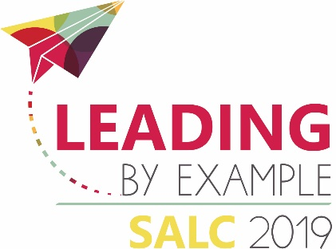
Call for Proposals
  - Southern Alberta Library Conference 2019
The Southern Alberta Library Conference (SALC) 2019 Planning Committee is inviting proposals for concurrent sessions for its conference in Lethbridge, AB, February 28th – March 2nd, 2019.

Leading by Example
A true leader models compassion, creates vision, builds community, and inspires trust. Join us at the 2019 Southern Alberta Library Conference to unleash your leadership potential and learn how your library can contribute to a thriving, healthy community.
The Committee invites session proposals that highlight ways in which libraries are modelling leadership and creating welcoming communities. The Committee will give preference to sessions that can be categorized into one of the following streams:
- Governance & Management
- Library Services & Programming
- Diversity & Inclusion
- Professional & Community Leadership
We encourage all proposals to consider how the subject matter can be applied to rural libraries.
Concurrent sessions are 75 minutes in length.

Lightning Strike Sessions
Lightning strike sessions will feature 3 separate presenters within the regular 75 minute timeslots. Each presenter will be given 15 minutes to present, with time at the end of the presentations for questions from the floor. The Committee is interested in hearing from individuals with experience in the following areas:
- Friends of the library societies
- Library management
- Library programming
- Community partnerships
- Grant writing
To submit a proposal, return this completed form to salc@chinookarch.ca
Deadline for proposal submission is September 7th, 2018. Should your proposal be accepted, you will receive free conference registration.
If you have any questions, please contact Kerby Elfring at Chinook Arch Regional Library System (kelfring@chinookarch.ca).
Contact name/Presenter 1: (first name, last name)
Email address:
Mailing address:
Phone number:
Names and email addresses for other presenters, if any:

Title of proposed session:
Please indicate whether this will be a regular session or a lightning strike session:
Regular: ☐ Lightning Strike: ☐
Please provide a very short summary of up to three sentences, suitable for session description in conference program.
Brief description of your proposed session. Please provide a description (up to 200 words) that will help the committee to decide on the program.

Brief biography for presenter 1 (one or two sentence bio for the conference program). If you wish you may also provide a slightly longer biography of up to 200 words for your introduction at the session.
Brief biography for Presenter 2:
Brief biography for Presenter 3:
Very brief summary (up to 50 words) of each presenter’s experience related to the topic.
Website (if applicable):

AV and room set up requirements:
Rooms for sessions are theatre style unless otherwise requested. Each room is equipped with a whiteboard or flipchart, laptop, and projector.
Please you the space below to request additions or changes:

Any other comments, questions, requests….

