OCADU Campaign – Digital Day of Action

#we loveOCADUlibrarians

Email template

Dear colleagues,
On Monday, May 31, 2021, the post-secondary sector across Ontario and Canada will hold a digital day of action to support the four librarians who have been terminated by OCADU Administration. The four librarians officially lose their jobs on June 1, 2021.
We are seriously concerned about the lack of collegiality and transparency in OCADU Administration’s decision to lay off the librarians. OCADU Faculty Association has been ramping up its campaign in support of the librarians – you can read letters of solidarity here.
We are also alarmed that this situation seems to reflect a growing trend in the post-secondary sector. OCADU Administration’s decision comes on the heels of Laurentian University’s financial crisis and the unfolding situation at University of Alberta.
We want to show our solidarity with the OCADU librarians as well as start vocalizing our concerns about this troubling sector-wide issue during the Digital Day of Action on Monday, May 31, 2021.
Please consider sharing this document with your colleagues across the country. Ask them to post on social media and use the hashtag #weloveOCADUlibrarians.
We also have shared two links that go with the shareable graphics below:
- An op-ed written by Min Sook Lee (@minsooklee), President of OCADU Faculty Association, Harriet de Sonnes Torrens, Chair of UTFA Librarians Committee and Terezia Zorić (@terezia_zoric), President of University of Toronto Faculty Association (UTFA)
https://utfa.medium.com/ocadus-decision-to-terminate-four-librarians-reflects-a-troubling-trend-in-the-post-secondary-4fdf11043cf1
- A petition to OCADU president, Ana Serrano
https://www.thepetitionsite.com/172/609/882/we-love-and-respect-ocadu-academic-professional-librarians-sign-our-petition-to-support-them/ Note that this second graphic (with three calls to action) must be posted with the petition link.
Please tag faculty associations, university unions, and other relevant post-secondary groups in your social media posts.
Thank you for participating.
[Name]

Tweet templates:

Style 1:
TEXT: Gutting libraries is a bad move for any educational institution. #weloveOCADUlibrarians
https://utfa.medium.com/ocadus-decision-to-terminate-four-librarians-reflects-a-troubling-trend-in-the-post-secondary-4fdf11043cf1
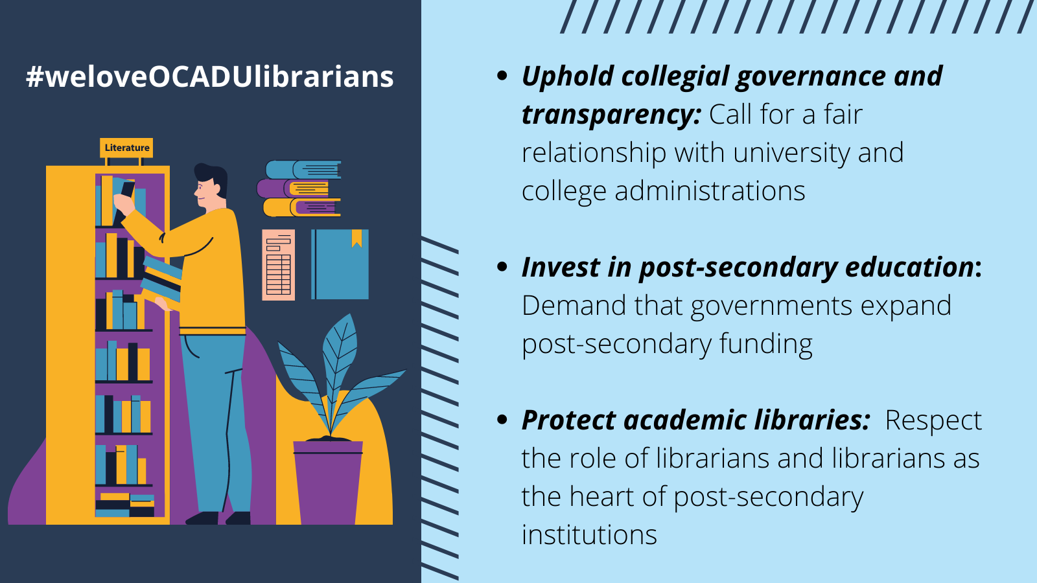

Style 2:
TEXT: University administrators need to stop operating like corporate CEOs. They need to respect collegial governance. #weloveOCADUlibrarians
https://utfa.medium.com/ocadus-decision-to-terminate-four-librarians-reflects-a-troubling-trend-in-the-post-secondary-4fdf11043cf1

Style 3:
TEXT: Provincial and federal governments must step up and invest in post-secondary education so we can stop the corporatization of universities. #weloveOCADUlibrarians
https://utfa.medium.com/ocadus-decision-to-terminate-four-librarians-reflects-a-troubling-trend-in-the-post-secondary-4fdf11043cf1

Style 4:
TEXT: I’m signing the petition to tell OCADU Administration that they should reverse the decision to terminate 4 senior librarians. #weloveOCADUlibrarians
https://www.thepetitionsite.com/172/609/882/we-love-and-respect-ocadu-academic-professional-librarians-sign-our-petition-to-support-them/
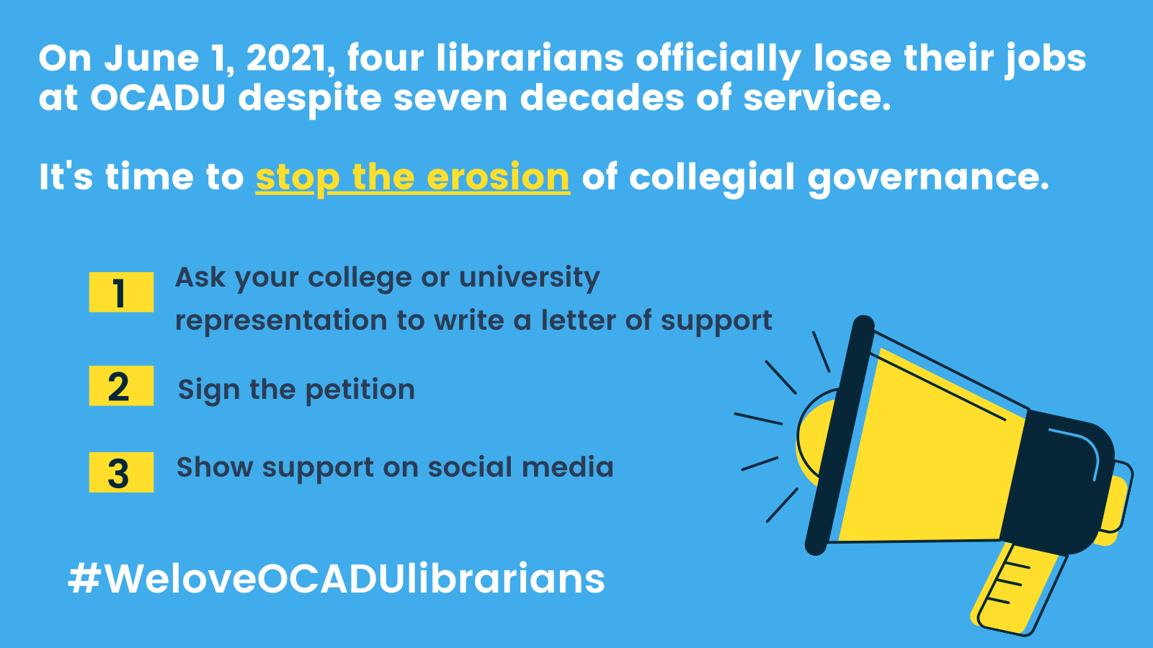

Style 5:
TEXT: I’m signing the petition to tell OCADU Administration that they cannot trade seven decades of institutional expertise for trivial cost savings. #weloveOCADUlibrarians
https://www.thepetitionsite.com/172/609/882/we-love-and-respect-ocadu-academic-professional-librarians-sign-our-petition-to-support-them/
Style 6:
TEXT: I’m signing the petition to tell OCADU Administration that they must not make decisions behind closed doors and without meaningful consultation from faculty, librarians, staff, and students. #weloveOCADUlibrarians
https://www.thepetitionsite.com/172/609/882/we-love-and-respect-ocadu-academic-professional-librarians-sign-our-petition-to-support-them/

Instagram graphics
